Skin Tone Heritability in Humans
Naomi Nkinsi
Honors 221
Winter 2016

Abstract
Variation in human skin tone, a trait that has long been used to divide and colonize those of the darker phenotype, is one such trait that has peeked interest as it has had both recent and historical sociological impacts. When examining a wide population of humans, it is clear that skin tone is a quantitative trait as variations fall within a spectrum as opposed to discrete categories. Since skin tone is a quantitative trait, multiple contributing factors such as genes and the amount of sun exposure an individual gets could contribute to the resulting phenotype. This study is continuation to a previous study in which I utilized survey techniques and conducted a data analysis to determine the heritability of skin tone. In my previous study, I had participants rank their own skin tone and that of their parents according to a scale and calculated heritability. In this study, the same general methods were used except I focused specifically on 20 mixed race families and ranked them myself. The purpose of this study was to determine if the heritability of skin tone would be different in mixed-race families. I hypothesized that while skin tone can very well be influenced by non-genetic factors like sun exposure, the majority of skin tone variation would be due to high heritability from parent to offspring. I hypothesized that this heritability shouldn’t be influenced by whether or not the families were mixed-race. The percent difference in genetic heritability of skin tones was 42.9352% which mixed-race families having a heritability of 63% and same-race a heritability of 97%. This data indicates that my hypothesis was not supported.

Introduction
Previous studies on this topic have found indications that human skin color is controlled by a combination of multiple genes (1) .This provides information indicating that variation in skin color has a genetic component. Furthermore, my previous study on this matter in which 69 individuals were asked to rank their skin tone and that of their parents according to a scale showed that 97% of variation in skin pigmentation was genetic. This information provided the basis of my study as I sought to determine if mixed-race families have similar hereditary patterns in skin tone or if environment played a greater role because their parents have greater genetic variation between the two of them. In this study, I hypothesize that the variation skin tone in human populations, specifically mixed-races families, arises from a combination of genetic and environmental factors to the same degree as in non-mixed-race families.

Methods
In order to test my hypothesis that variation in human skin tone is mostly due to genetic factors in mixed-race families, I conducted a survey of offspring and their parents. Using photos of mixed-race families obtained through online searches and social media sites such as Facebook and Instagram, I ranked the skin tone of the parents and offspring in 20 unrelated families according to the Fitzpatrick skin tone scale (Fig. 1) and formatted these results into a table (Fig. 2). Each family was only ranked once, and I alone ranked the skin tone of the individuals based on plain eye observations. After collecting my data, I then created a graph that plots the midparent skin tone against the mid offspring skin tone and measured the slop of the best-fit line to determine heritability. From there, I compared the heritability of skin tone in mixed versus nonmixed families by calculating a percent difference (Fig. 4).

Results and Conclusions
When determining heritability of a trait, the slope of the best fit line when offspring value and mid-parent value are plotted against one another can give an accurate estimate. In my experiment, this slope value was 0.625, indicating that about 67% of variation due to skin tone (Fig. 3) in humans is hereditary while the other 33% may be due to environmental factors. In my previous study, the slope value was 0.9667, indicated that about 97% of variation in skin tone is hereditary. There is a percent difference of 42.9352% between the two values. My hypothesis that variation in human skin pigmentation due to genes is the same in mixed-race and same race families was not supported.

Discussion
This investigation was restricted in many ways that may have altered the results or led to poor interpretation. For example, a much larger sample size would increase the accuracy of the predicted slope as more data points would be plotted. In this study, I only surveyed 20 unique families while the previous study used for comparison had 69 unique respondents. I compared the results of the two studies, but this comparison may not have been fair because the previous study had much more robust data. Furthermore, the survey results were based solely on my interpretation of photos that I found whereas those of the previous study were conducted by multiple individuals and were based on intimate knowledge of the individuals being ranked, not photos that could have been edited or otherwise altered.
A better experiment for this question would have been to separate children from their biological parents and place them with non-biological foster parents as one experimental group. I would conduct this experiment with two sets of children: offspring of both same-race and mixedrace parents to see if the heritability of skin tones in the offspring varied between the two groups. The other control group would have children remain with their biological parents. Although this alternative study would probably provide the most non-biased and robust results, it would not be ethical. Perhaps I could find animal models that have similar skin tone genes to conduct this experiment on, but these results may not necessarily be transferable to humans.

Data and Figures
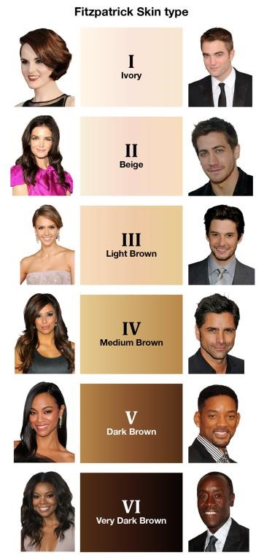

Figure 1. A screen shot of the Fitzpatrick skin tone scale used in the online survey provided for participants is shown above. Note that answers were collected in a multiple choice format and that visual aids were provided to ensure accurate answer selection

 | Mother's Skin Tone | Father's skin tone | Average parent skin tone | Child's skin tone
Family 1 | 3 | 6 | 4.5 | 4
Family 2 | 4 | 1 | 2.5 | 3
Family 3 | 4 | 2 | 3 | 4
Family 4 | 2 | 6 | 4 | 4
Family 5 | 4 | 3 | 3.5 | 3
Family 6 | 4 | 6 | 5 | 4
Family 7 | 2 | 5 | 3.5 | 3
Family 8 | 3 | 5 | 4 | 5
Family 9 | 3 | 6 | 4.5 | 4
Family 10 | 3 | 4 | 3.5 | 4
Family 11 | 3 | 3 | 3 | 3
Family 12 | 5 | 2 | 3.5 | 3
Family 13 | 3 | 3 | 3 | 3
Family 14 | 4 | 3 | 3.5 | 3
Family 15 | 5 | 2 | 3.5 | 3
Family 16 | 2 | 6 | 4 | 5
Family 17 | 2 | 6 | 4 | 5
Family 18 | 3 | 6 | 4.5 | 4
Family 19 | 2 | 5 | 3.5 | 4
Family 20 1 6 3.5 4

Figure 2. The table above depicts individual data points collected via surveying techniques. The Mid-Parent value was calculated by finding the average of the maternal and paternal values.

y = 0.625x + 1.4375

0
1
2
3
4
5
6
2
2.5
3
3.5
4
4.5
5
5.5
Mid Offspring Value

Mid Parent Value

Heritability of Skin Tone

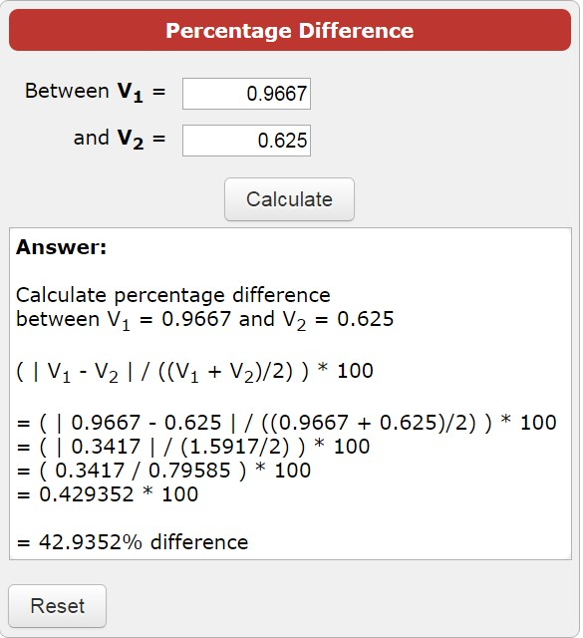
sampling size.
Figure 3.
The graph depicts a linear association between
mid
-
parent

skin tone value and child

skin tone value. There is
variation along the line of best fit which may be decreased with larger

Figure 4. The image depicts the calculation of percent difference between the heritability values of the two studies.

Works Cited
1. Gregory S Barsh. 2013. What Controls Variation in Human Skin Color?. PLoS Biol. 1(1):
e27.

